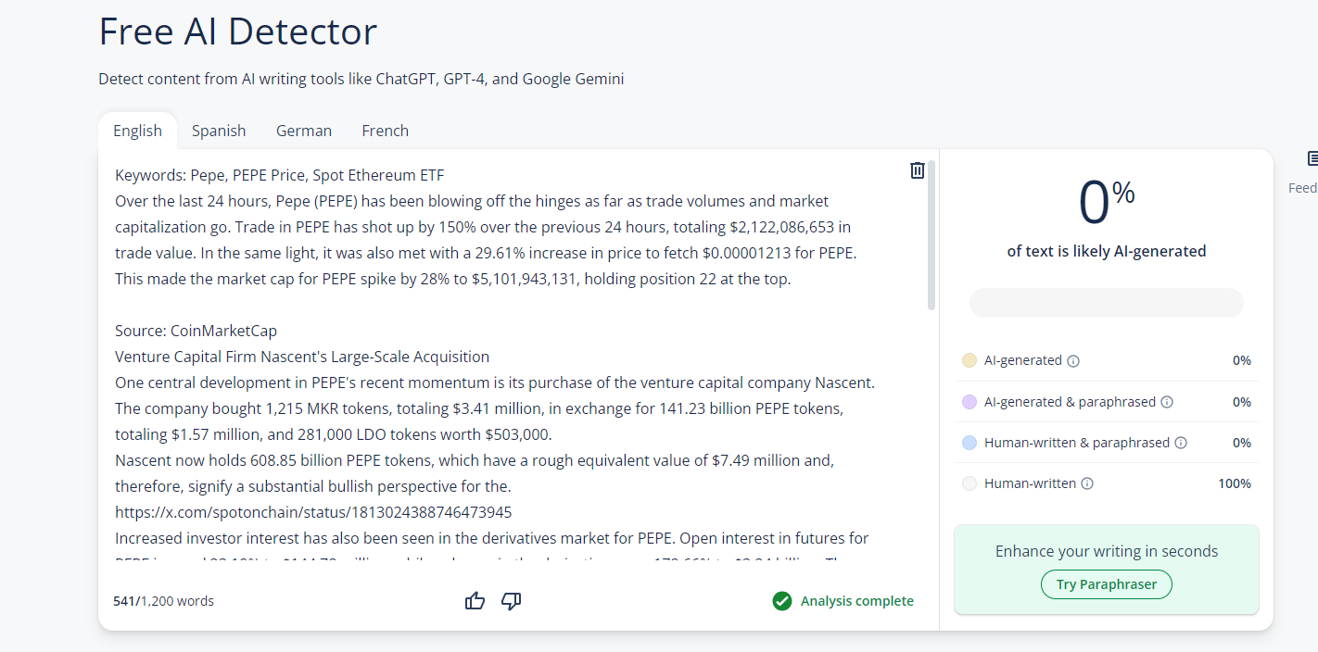**Pepe Price Analysis: PEPE Price Surges 29% as Trading Volume Skyrockets 150%**

Author: Kelvin Munene

Meta Description: PEPE surges 29.61% in 24h, reaching a $5.1B market cap and becoming the 22nd largest crypto, fueled by high trading volume and venture capital interest.

Keywords: Pepe, PEPE Price, Spot Ethereum ETF

Over the last 24 hours, Pepe (PEPE) has been blowing off the hinges as far as trade volumes and market capitalization go. Trade in [PEPE](https://sfctoday.com/pepe-price-analysis-pepe-price-falters-as-whale-transactions-decline/) has shot up by 150% over the previous 24 hours, totaling $2,122,086,653 in trade value. In the same light, it was also met with a 29.61% increase in price to fetch $0.00001213 for PEPE. This made the market cap for PEPE spike by 28% to $5,101,943,131, holding position 22 at the top.

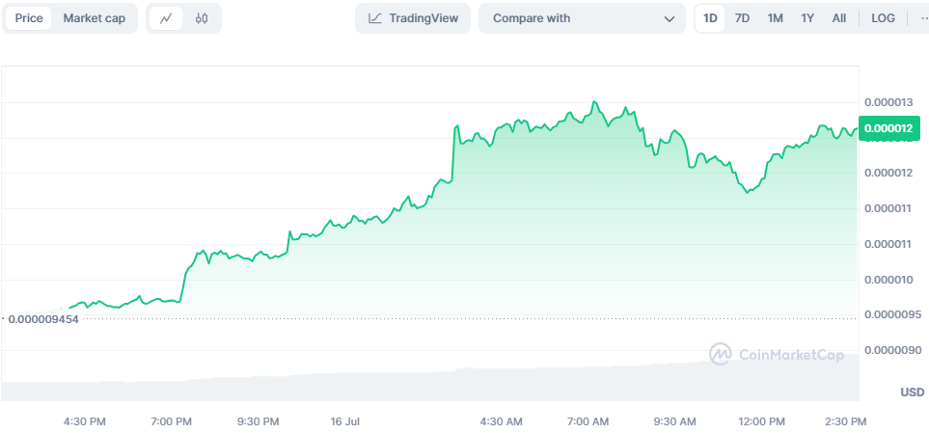

Source: [CoinMarketCap](https://coinmarketcap.com/currencies/pepe/)

## **Venture Capital Firm Nascent's Large-Scale Acquisition**

One central development in [PEPE's](https://sfctoday.com/pepe-pepe-price-surges-over-2-as-bullish-momentum-strengthens/) recent momentum is its purchase of the venture capital company Nascent. The company bought 1,215 MKR tokens, totaling $3.41 million, in exchange for 141.23 billion PEPE tokens, totaling $1.57 million, and 281,000 LDO tokens worth $503,000.

Nascent now holds 608.85 billion PEPE tokens, which have a rough equivalent value of $7.49 million and, therefore, signify a substantial bullish perspective for the.

<https://x.com/spotonchain/status/1813024388746473945>

Increased investor interest has also been seen in the derivatives market for PEPE. Open interest in futures for PEPE jumped 23.19% to $144.78 million, while volumes in the derivatives rose 178.66% to $3.24 billion. The numbers clearly state that the speculation over the future price of PEPE is on the rise, boosting bullish sentiment toward the token.

## **PEPE Price Prediction: Eyeing New Peaks**

Remarkably, the price of PEPE has been heavily influenced by the preliminary approval of the spot Ethereum ETFs. In the event that such a bullish feeling continues, the price of PEPE would lift to $0.00001730, 41% up from the all-time high.

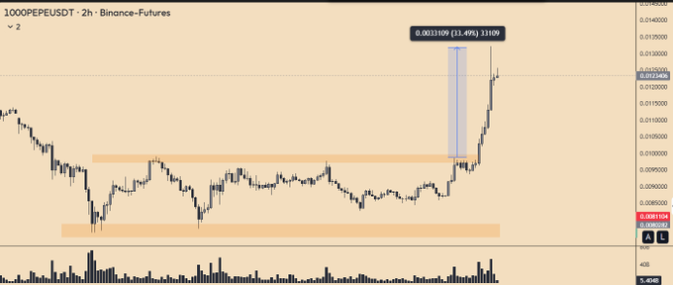

Recently, PEPE has tested the significant resistance levels. The token has just broken out of a falling wedge pattern with a 29% move. According to analysts, it should close above $0.00001350 so as to confirm the uptrend. Technical indicators are also in support after the RSI and CMF turned very bullish.

## **Bullish Outlook for PEPE**

The reaction to Nascent's acquisition was upbeat; the price of [PEPE](https://sfctoday.com/pepe-coin-rebounds-above-0-000009-with-renewed-momentum/) rallied by 23.42% to $0.00001201. This immense pressure in buyouts is emanating from the Nascent camp, giving hope for good days to come. The interest of investors has been boosted more so with the derivative market on the rise.

As of now, the price of PEPE is trying to break through the resistance level at $0. 000012-0. 000013. If the consolidation happens above these levels, the new bullish phase will be expected to happen. On the flip side, support is seen at $0. 000010 and $0. 0000078, which can help halt the decline if resistance remain intact.

<https://x.com/Yuriy_Biko/status/1812836778337788214>

Market analysts believe that if the momentum prevails, PEPE may trade up at 41% to $0.00001730. A pertinent part of their forecast is a very positive market sentiment and growing interest among investors in the derivatives market. The most crucial area of resistance that traders have to focus on is the breakout and consolidation above $0. 00001350.

From the chart, we can see that PEPE is still in an upward trend given that it is trading above the 200-day Simple Moving Average which is a positive sign in the longer run. Moreover, the Relative Strength Index of PEPE is 44. 9, which is a level of support that is usually seen in bullish markets.